Teachers
------------------------------------------------------------------------------------------------------------------------------
Learning about Civics and Citizenship fosters commitment to values of democracy, equity and justice and supports our students’ journey to becoming active and informed citizens.
Queensland teachers contribute to learning about democracy every day.
Australian Curriculum
Queensland schools are required to teach the Australian Curriculum: Civics and Citizenship in Years 3 to Year 10.
The Australian Curriculum: Civics and Citizenship aims to ensure students develop:
- a lifelong sense of belonging to, and engagement with, civic life as an active and informed citizen in the context of Australia as a secular democratic nation with a dynamic, multicultural, multi-faith society and a Christian heritage
- knowledge, understanding and appreciation of the values, principles, institutions and practices of Australia’s system of democratic government and law, and the role of the citizen in Australian government and society
- skills, including questioning and research; analysis, synthesis and interpretation; problem-solving and decision-making; communication and reflection, to investigate contemporary civics and citizenship issues and foster responsible participation in Australia’s democracy
- the capacities and dispositions to participate in the civic life of their nation at a local, regional and global level and as individuals in a globalised world.
There are multiple ways that schools can implement Civics and Citizenship:
- Years 3 to 7 Humanities and Social Sciences, one sub-strand
- Years 3 to 8 Civics and Citizenship, as a single subject
- Years 9 and 10 Civics and Citizenship, as a student elective
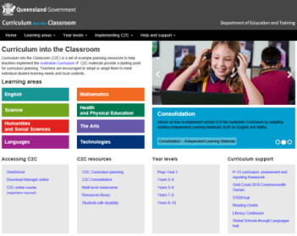
- Years 11 and 12 students choose from the senior secondary subjects offered by the Queensland Curriculum and Assessment Authority, for example Legal Studies.
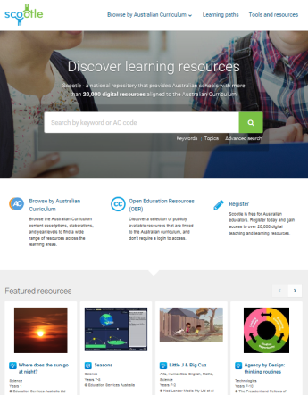
Queensland teachers are supported by Curriculum into the Classroom (C2C) materials for Civics and Citizenship. These materials include year level plans, topic outlines, teaching sequences, summative assessment and resources.
Queensland state school teachers access the C2C materials on the C2C website. Queensland non-state school teachers access C2C using Scootle.
Schools Constitutional Conventions
Queensland students have the opportunity to participate in the Schools Constitutional Conventions. These conventions:
- educate secondary students about the Australian Constitution and how it guides democracy
- include opportunities for students to listen to speakers presenting perspectives on a constitutional issue and to participate in debates and plebiscites
- provide the basis for the election of Queensland's delegate team to attend the National Schools Constitutional Conventions (NSCC) held in Canberra each year.
Additional resources and materials can be found through the links below:
Years 3 - Community and belonging
Difference differently (Together for Humanity Foundation) http://differencedifferently.edu.au
Australia Day, Citizenship Ceremonies (National Australia Day Council) http://www.australiaday.org.au/australia-day/australia-day-ceremonies/citizenship-ceremonies/

Year 4 - Rules and laws
The law (Parliamentary Education Office) http://www.peo.gov.au/multimedia/image-library/the-law.html

Year 5 - Representation and participation
Practise voting - House of Representatives (Australian Electoral Commission) http://www.aec.gov.au/Voting/How_to_vote/practice/practice-house-of-reps.htm

Year 7 - Shaping democratic Australia
Constitution (ABC TV Behind the News) http://www.abc.net.au/btn/story/s3939299.htm

Year 7 - Justice
Magistrates Court virtual tour (Queensland Government) https://www.qld.gov.au/law/court/going-to-court/going-to-court/magistrates-court-virtual-tour/

Year 8 - Australian Citizenship
http://www.civicsandcitizenship.edu.au/cce/gallery_of_australian_biographies,14538.html
.
Year 9 - Law-making
Parties control parliament (Discovering Democracy Units) http://www1.curriculum.edu.au/ddunits/units/ms1parties-glance.htm

Year 10 - A resilient democracy
Treaty making process (Australian Government, Department of Foreign Affairs and Trade) https://www.dfat.gov.au/treaties/making/

Additional Guide to Democracy resources are currently being developed for Queensland teachers. The new resources will build on the great work already happening in Queensland schools.
Keep checking here for new Guide to Democracy activities and resources for teachers.

